API Reverse Engineering using mitmproxy & Postman

1. Introduction
Modern web applications heavily rely on APIs (Application Programming Interfaces) to communicate between the frontend (UI) and backend (server). However, in many real-world scenarios, API documentation is not publicly available.
API Reverse Engineering is the process of analyzing network traffic to:
- Discover hidden API endpoints
- Understand request/response structures
- Reconstruct API behavior without documentation
In this project, a vulnerable web application (crAPI) is used to demonstrate how APIs can be reverse engineered using traffic interception tools.

2. Objective
The main objectives of this project are:
- To capture API communication between client and server
- To identify and reconstruct hidden API endpoints
- To convert captured traffic into structured API documentation
- To test and validate APIs using Postman
- To understand how attackers analyze APIs in real-world scenarios

3. Tools Used
- Mitmproxy
- mitmproxy2swagger
- Postman
- Docker
- Kali Linux

4. Project Architecture (Simple Understanding)
User → Browser → Proxy (mitmproxy) → Web Application (crAPI)
- Browser sends requests
- mitmproxy captures them
- Requests are analyzed and converted into API documentation

5. Methodology
Step 1: Setup Environment
The vulnerable application (crAPI) was deployed using Docker:
docker-compose up
This started all required services (frontend, backend APIs, database).
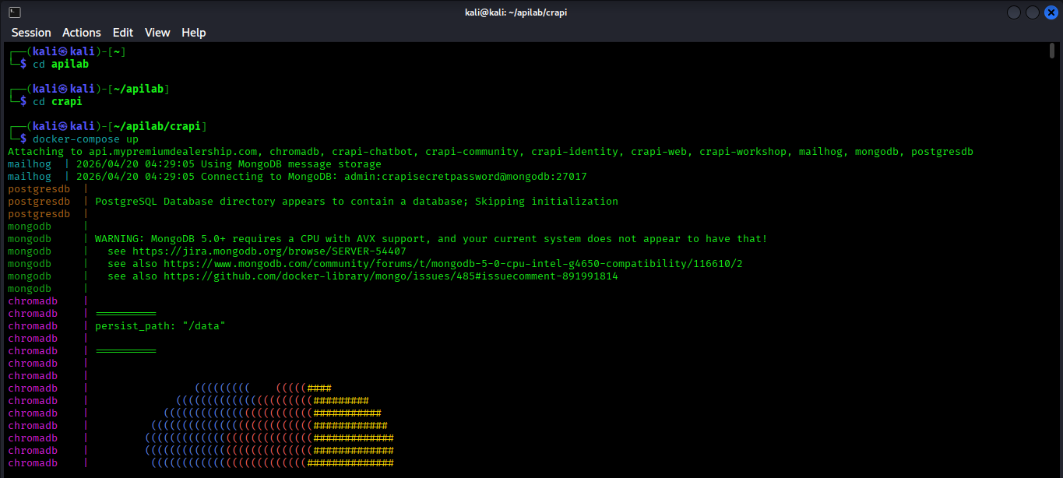

Step 2: Start Traffic Interception
mitmproxy was started using:
mitmweb
- Proxy configured in browser: 127.0.0.1:8080
- All HTTP requests were routed through mitmproxy

Step 3: Interact with Application
To capture maximum API endpoints, multiple actions were performed:
- User Registration (Signup)
- Login
- Viewing Dashboard
- Accessing Shop
- Viewing Orders
This step is important because APIs are only captured when they are used.
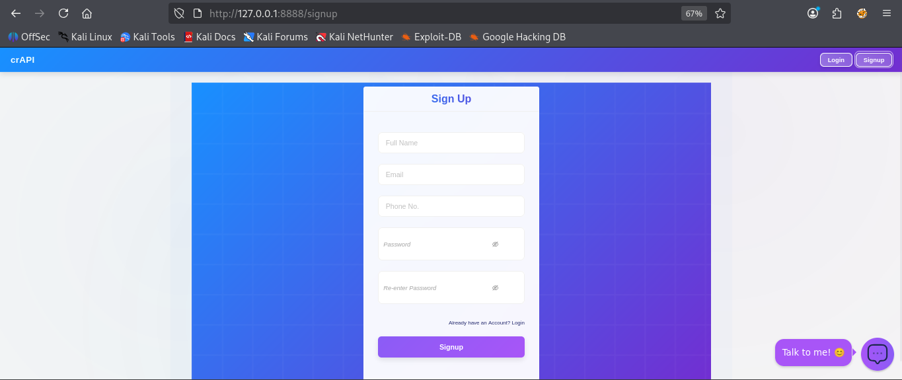
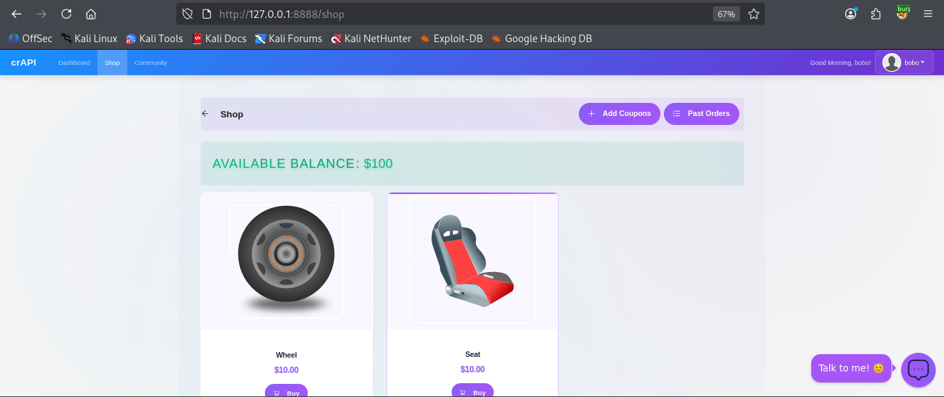
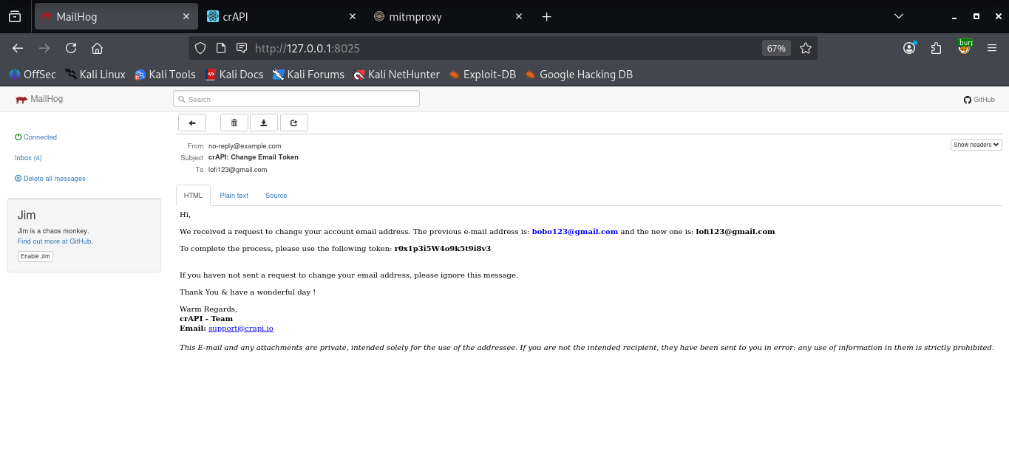

Step 4: Capture and Save Traffic
All intercepted traffic was saved as a file:
flows
This file contains:
- API endpoints
- Request methods (GET, POST)
- Parameters
- Responses
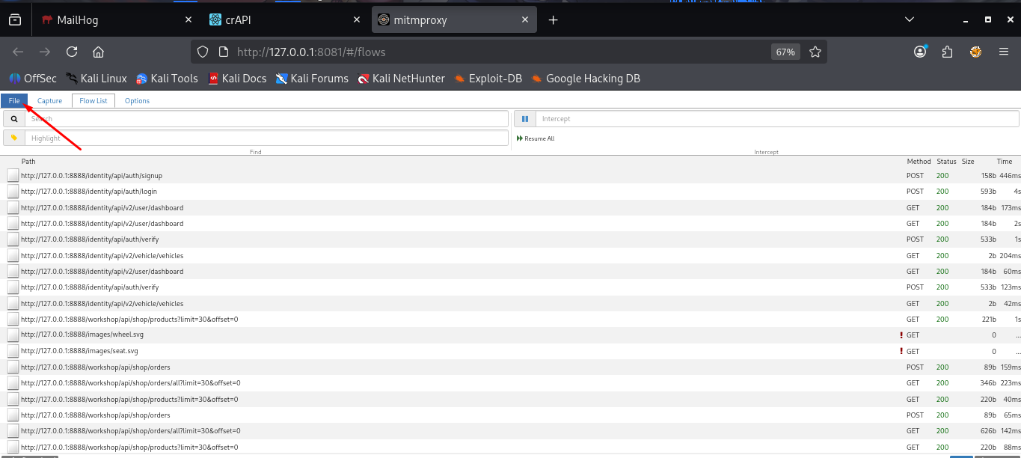

Step 5: Convert Traffic to API Documentation
Captured traffic was converted into Swagger format using:
mitmproxy2swagger -i ~/Downloads/flows -o spec.yml -p http://127.0.0.1:8888 -f flow
This generated a file:
spec.yml
This file acts as API documentation.
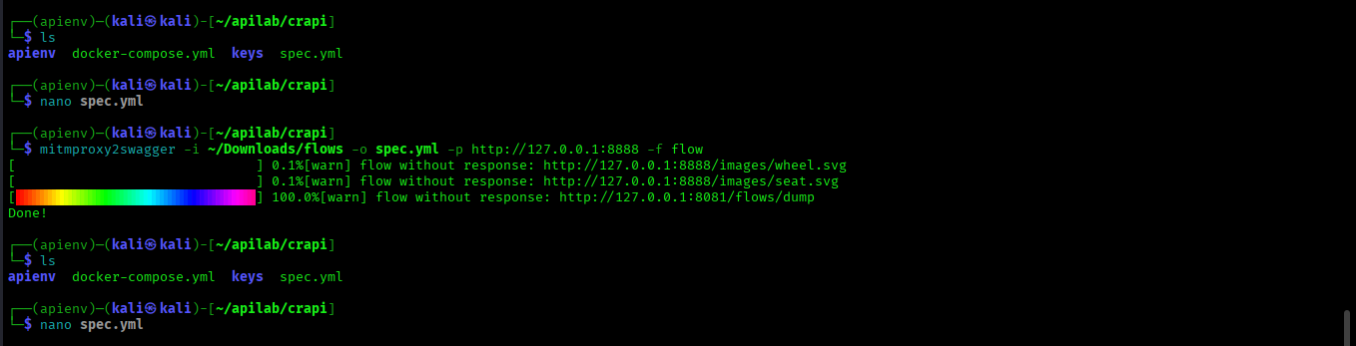
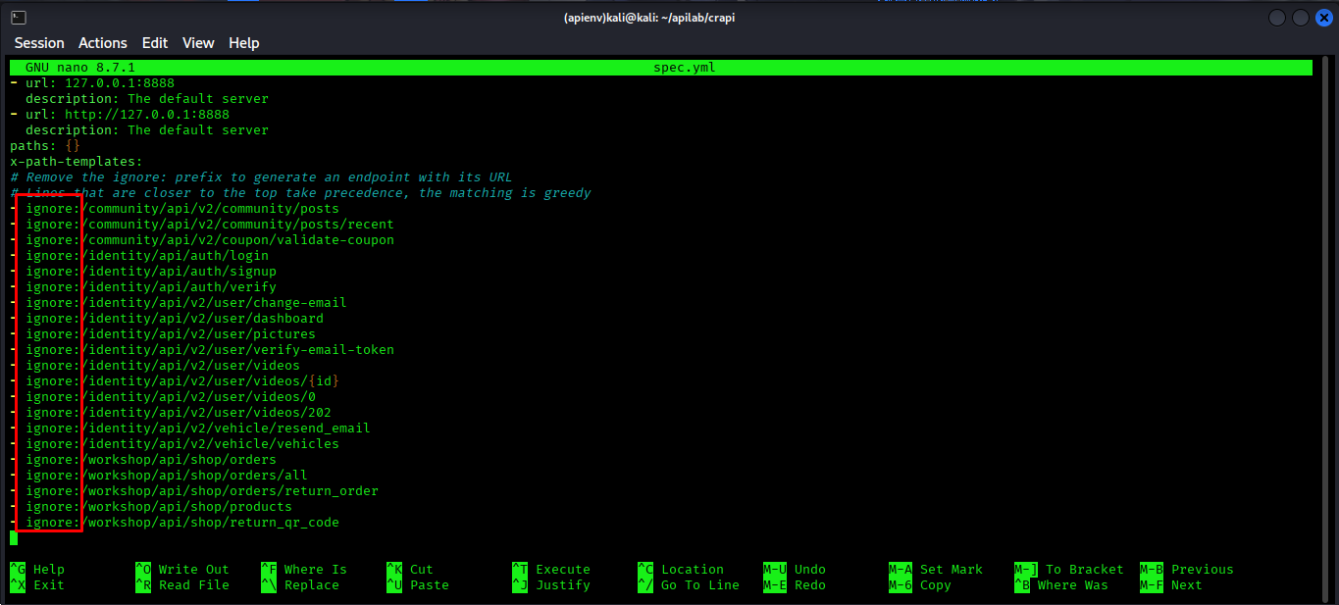

Step 6: Extract and Understand API Endpoints
From the generated file, important endpoints were identified:
- /identity/api/auth/login → User login
- /identity/api/auth/signup → User registration
- /identity/api/v2/user/dashboard → User data
- /workshop/api/shop/products → Product list
- /workshop/api/shop/orders → Orders
👉 These endpoints represent backend functionalities of the application.

Step 7: Import into Postman
The generated spec.yml file was imported into Postman.
This automatically created:
- API collection
- Organized endpoints
- Ready-to-test requests
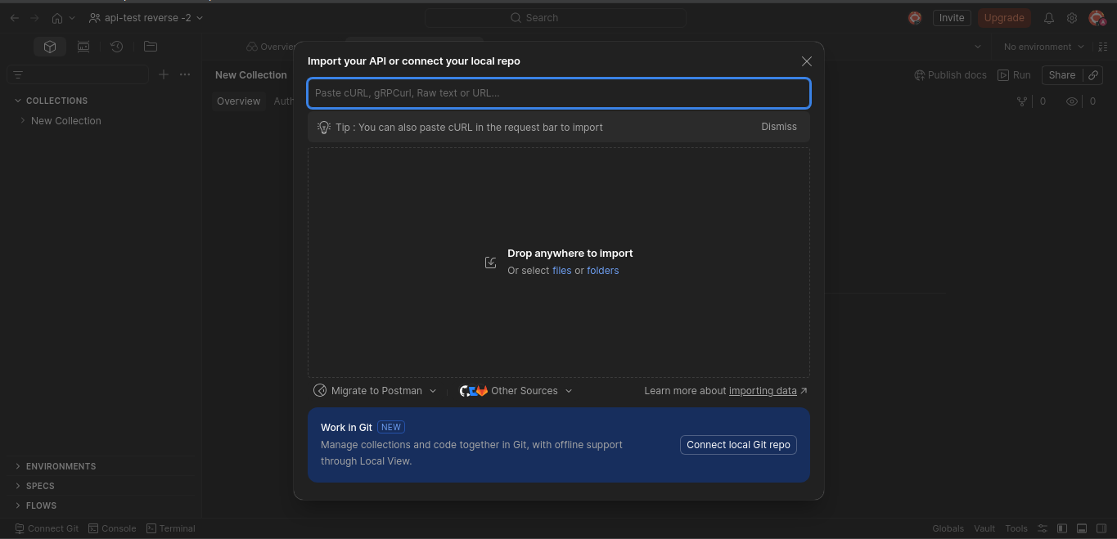
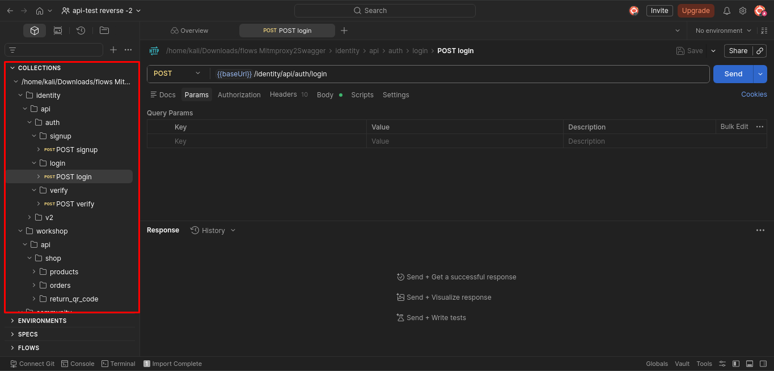

Step 8: API Testing
Using Postman:
- Login API was tested with JSON request body
- Token-based authentication was observed
- APIs were validated by sending requests and analyzing responses
Example request:
{
"email": "user@example.com",
"password": "password123"
}
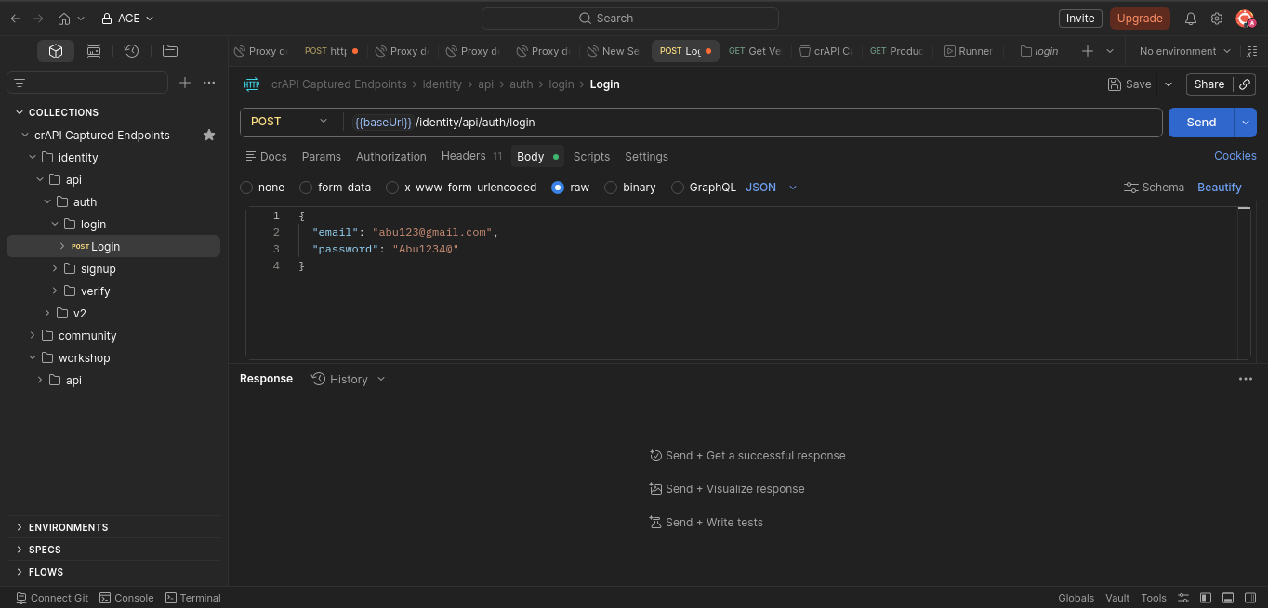

6. Results
- Successfully captured API traffic
- Identified hidden API endpoints
- Generated API documentation (Swagger format)
- Imported and tested APIs using Postman
- Understood backend communication flow

7. Real-World Application
This technique can be used when:
- API documentation is not available
- Testing third-party applications
- Performing security assessments
- Bug bounty hunting
Attackers use the same process to:
- Discover hidden endpoints
- Test for vulnerabilities
- Access unauthorized data

8. Conclusion
This project demonstrates that APIs can be fully understood and reconstructed without official documentation by analyzing network traffic.
It highlights:
- Importance of API security
- Need for proper authentication mechanisms
- Risks of exposing sensitive endpoints

